1B ANOVA (PlantGrowth Dataset)
Introduction
A one-way analysis of variance (ANOVA) was conducted to determine whether there are statistically significant differences in plant weight between different treatment groups.

Checking Assumptions
Assumption #1: You have one dependent variable that is measured at the continuous level.
Remark: The dependent variable is weight, which is measured on a continuous scale.
Assumption #2: You have one independent variable that consists of three or more categorical,
independent groups.
Remark: The independent variable is group, consisting of three independent groups: ctrl, trt1, and trt2.
Assumption #3: You should have independence of observations, which means that there is no
relationship between the observations in each group of the independent variable or among the
groups themselves.
Remark: Each observation is independent since plant measurements are taken separately across groups.
Assumption #4: There should be no significant outliers in the three or more groups of your
independent variable in terms of the dependent variable.
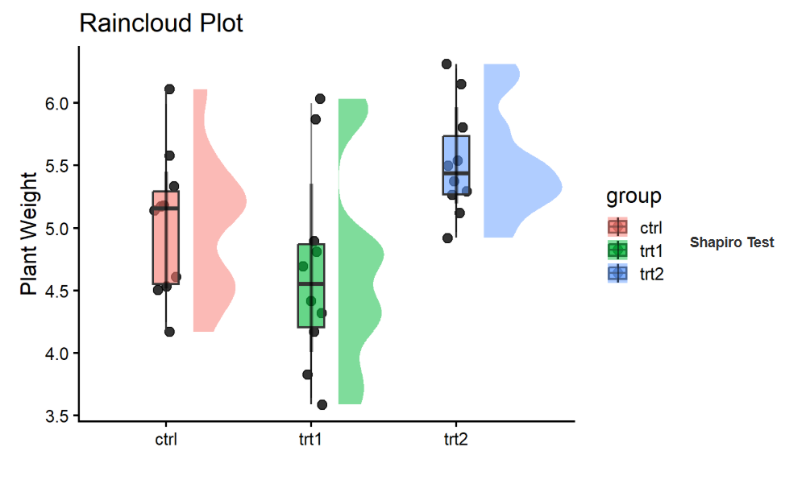
Remark: There are no extreme outliers based on visual inspection (e.g., raincloud plot).

Assumption #5: Your dependent variable should be approximately normally distributed for each
group of the independent variable.
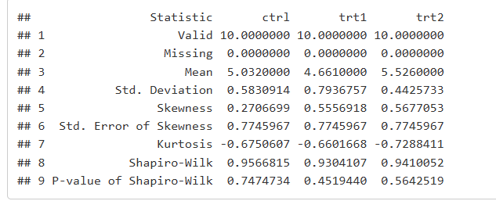
Remark: The dependent variable is approximately normally distributed within each group (can be checked using Shapiro-Wilk test, typically p > 0.05).
Assumption #6: You have homogeneity of variances (i.e., the variance of the dependent variable
is equal in each group of your independent variable).

Remark: Variances are approximately equal across groups (can be tested using Levene’s test; usually satisfied for this dataset).
Computation
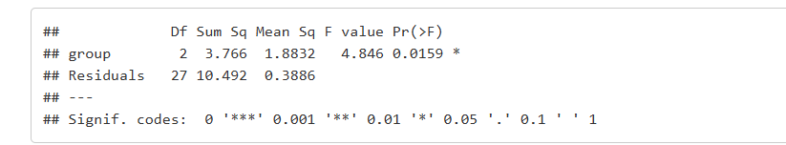

Post Hoc Comparisons
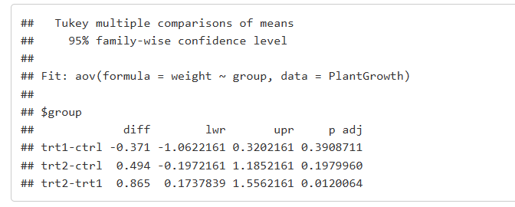
Reporting
A one-way ANOVA was conducted to determine if plant weight was different across treatment groups (ctrl, trt1, trt2). There were no significant outliers, data were approximately normally distributed for each group, and there was homogeneity of variances. Plant weight was statistically significantly different between groups, F(2, 27) = 4.846, p = 0.0159. Plant weight was lowest in the trt1 group (M = 4.66, SD = 0.79), followed by the ctrl group (M = 5.03, SD = 0.58), and highest in the trt2 group (M = 5.53, SD = 0.44). Tukey post hoc analysis revealed that the difference between trt2 and trt1 was statistically significant, while other group comparisons were not significant.

